Applecross SHS

3A Biological Sciences

Test 2 – Homeostasis

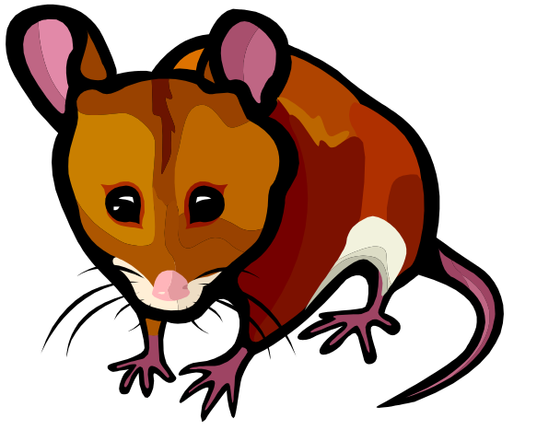
Microsoft clipart

This test consists of two parts

Part A – Multiple Choice – 20 marks
Part B – Short Answer – 30 marks

PLEASE DO NOT MARK THIS QUESTION BOOKLET

Part 1 – Multiple Choice (20 marks)

Mark the most correct response on the answer sheet provided

- The reason plants growing in hot climates reduce the amount of photosynthesis during the hottest part of the day is

  - the stomata close so no carbon dioxide can diffuse into the air spaces in the leaf.
  - there is no water available for photosynthesis.
  - high temperature inactivate the enzymes used during photosynthesis.
  - the guard cells become too turgid at high intensities of light.

- A plant which has leaves with a very thick cuticle would have some survival advantages in the

  - tropical rain forest
  - desert
  - coastal plain
  - mountain ranges

- For animals living in freshwater excretion of water is a necessity because;

  - their cells cannot retain high concentrations of water.
  - water will always go from a high concentration of salts to a lower concentration.
  - water in the external environment has a higher concentration of dissolved salts than what is found inside their cells.
  - their body cells naturally gain water because of their relatively high salt concentration.

- Most birds excrete their toxic waste in the form of

  - urea
  - ammonia
  - urine
  - uric acid

The following table indicates daily heat losses by a human adult in a temperate climate

Method of heat loss | Amount (kilojoules)
Conduction/radiation | 7700
Evaporation from skin | 1800
evaporation from lungs | 800
warming air in lungs | 300
urine/faeces | 200
Total daily loss | 10 800kJ

- Which method shown in the above table would increase the most if the airtemperature was to rise?

  - conduction/radiation
  - evaporation from the skin
  - evaporation from the lungs
  - urine/faeces

- Which of the following two adaptations would be most likely for an animal living in Antarctica?

- large, round shape.
- sparse, light coloured fur.
- active during daylight hours.
- excretion of uric acid crystals.

  - (i) and (ii)
  - (i) and (iii)
  - (iii) and (iv)
  - (ii) and (iv)

- In endothermic animals how is metabolic rate related to body size?

  - As size increases so too does the metabolic rate per gram of body mass.
  - As size decreases the metabolic rate per gram of body mass increases.
  - As size increases the metabolic rate decreases overall.
  - Metabolic rate is constant per gram of body mass regardless of size.

The following graph shows the body temperature of an insect in different situations and the air temperature.

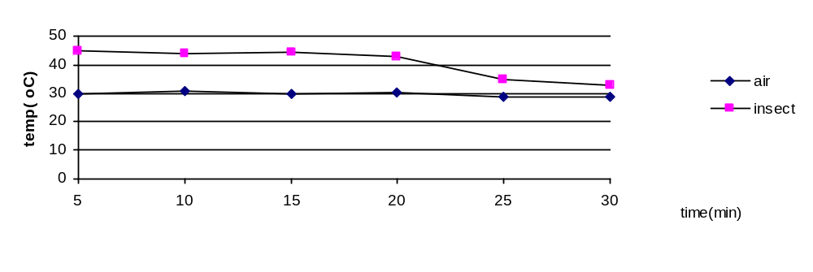

- From the time period of 20 to 30 minutes the insect was in a shaded area. The fact that it’s body temperature dropped is due to the fact that the insect is

  - exothermic
  - endothermic
  - homeothermic
  - ectothermic.

- At what time did the insects’ body temperature reach 37°C ?

  - 20 minutes
  - 21 minutes
  - 23 minutes
  - 25 minutes

- During the breakdown of proteins ammonia is produced. In mammals this compound is converted into urea for excretion because

  - urea is easier to excrete.
  - ammonia is toxic to cells.
  - ammonia is not soluble in water.
  - urea can be recycled.

The graph below shows the rate of oxygen consumption of a marsupial at different air temperatures.

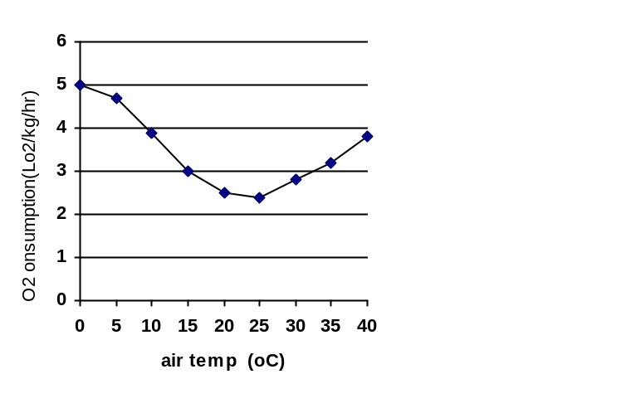

- The data graphed above indicates that;

  - a high rate of oxygen consumption can cause a rise in body temperature.
  - the marsupial cannot survive at air temperatures lower than 10ºC.
  - in cold weather marsupials reduce the energy they use.
  - energy is used up by the marsupial to maintain a constant body temperature.

- Receptors are an important part of the homeostatic mechanism. The function of a receptor is to;

  - Interpret information received from its environment and sends it to the modulator.
  - Receive information and communicate with with the modular or /transmitter.
  - Respond to a stimulus from the effector.
  - Create a stimulus which is sent to the effector.

- Which of the following correctly matches the state of the guard cells to the opening or closing of the stomatal pores?

  - If guard cells are flaccid, stomatal pores are kept open.
  - If the osmotic pressure in guard cells is higher than the surrounding epidermal cells then stomatal pores will be open.
  - If the osmotic pressure in guard cells is lower than the surrounding epidermal cells then stomatal pores will be open.
  - If guard cells are turgid, stomatal pores are kept closed.

Question 14 and 15 refer to the following information.

Resting mammals keep their internal body temperature close to 37 degrees Celsius. If the external environment is much colder, blood from close to the skin surface may be cooler. When cooled blood reaches part of the brain, a hormone is released causing a sequence of events which results in metabolic heat being produced in the animal’s liver.

- Which of the following correctly identifies the stimulus and response in this example?

  - The cold environment is the stimulus and the cooling of the blood close to the skin is the response.
  - Cool blood temperature is the stimulus and metabolic heat production by the liver is the response.
  - Cool blood reaching the brain is the stimulus and the release of the hormone is the response.
  - The cold environment is the stimulus and the release of the hormone is the response.

- Which of the following best describes negative feedback as a mammal regulates body temperature?

  - Blood which has been warmed by the liver eventually reaches the brain. Release of the hormone is then stopped.
  - Loss of heat from blood passing close to the skin causes the blood temperature to drop. Cool blood reaching the brain is negative feedback.
  - Blood, which has been warmed by the liver, circulates through the body. This takes heat energy to the skin, preventing the body from becoming cold.
  - Metabolic heat production by the liver helps to balance loss of heat from the skin.

- Which of the following organisms would you expect to normally produce the most dilute urine?

  - man
  - bird
  - salt water fish
  - fresh water fish

The following information refers to question 17 and 18.

In the hot, dry and sparsely vegetated Mohave Desert in California live two species of ground squirrel: the antelope ground squirrel and the Mohave ground squirrel. These two species are similar in many ways, and have been classified into the same genus. Both species live in burrows at night-time and are active above ground during the daytime, when they feed on small amounts of plant and insect life that is available.

- Which of the following behaviour patterns is least expected in a desert animal?

  - Feeding in the daytime
  - Resting in burrows
  - Eating insects
  - Becoming inactive in the hotter, drier months

- The Mohave ground squirrel, unlike the antelope ground squirrel, spends seven of the driest months, from August to March, in an inactive state in its burrow. From March to August, when conditions are more favourable, it becomes active again, coming up to feed in the daytime. During these five months the squirrels put on weight and store fat in their bodies. The advantage of this period of inactivity to the Mohave ground squirrel is that it

  - Helps it to conserve energy.
  - Helps it to conserve water.
  - Reduces competition with the antelope ground squirrel.
  - All of the above.

- Kangaroo rats usually eat only dry seeds. They do not drink water. They survive because

  - They do not excrete their nitrogenous waste dissolved in water
  - Their tissues contain a low percentage of water
  - No water is lost during breathing
  - Sufficient water for their needs is produced during the breakdown of food.

- Land animals can have a problem maintaining water balance in arid environments. Which of the following components can a mammal use to control water loss?

  - Water vapour during breathing
  - Dry urea pellets in the faeces
  - Urine volume and concentration
  - Sweating
3A Biological Sciences

Test 2 - Homeostasis

Name _______________________________________________________________________

Part 1 - Multiple choice answers 20 marks
Indicate the correct answer for each question below.

1 | [A] | [B] | [C] | [D] |  | 6 | [A] | [B] | [C] | [D] |  | 11 | [A] | [B] | [C] | [D] |  | 16 | [A] | [B] | [C] | [D]
2 | [A] | [B] | [C] | [D] |  | 7 | [A] | [B] | [C] | [D] |  | 12 | [A] | [B] | [C] | [D] |  | 17 | [A] | [B] | [C] | [D]
3 | [A] | [B] | [C] | [D] |  | 8 | [A] | [B] | [C] | [D] |  | 13 | [A] | [B] | [C] | [D] |  | 18 | [A] | [B] | [C] | [D]
4 | [A] | [B] | [C] | [D] |  | 9 | [A] | [B] | [C] | [D] |  | 14 | [A] | [B] | [C] | [D] |  | 19 | [A] | [B] | [C] | [D]
5 | [A] | [B] | [C] | [D] |  | 10 | [A] | [B] | [C] | [D] |  | 15 | [A] | [B] | [C] | [D] |  | 20 | [A] | [B] | [C] | [D]

Part 2 – Short answer 30 marks
Write your response in the space provided for each question. Answer all the questions.

- The homeostasis of the internal environment is a major requirement of all living organisms.

  - State why the following conditions must be controlled by the process of homeostasis for the effective functioning of the organism.
Carbon dioxide: too high a level lowers pH (1)which leads to protein/enzyme denaturation.(1) or affects respiration rate (1)
Subtotal 2
Salts: Water moves by osmosis (1)from areas of low salt concentration into areas of high salt concentration(1) causing cells to gain or lose water(1)
Salts needed for specific functions(1) eg Na for nerve transmission. /Ca for bone and shell formation/ Mg for chlorophyll formation(1)
Or general answer: salts dissociate in body fluids (1) disrupting metabolic processes (1) (any two) or : too much salt leads to cells dehydrating (1) and converse (1)
Subtotal 2
2x2=4 marks

  - Marine and freshwater fish balance the loss and gain of salt and water using different mechanisms depending on their environment.

Complete the table below the comparing the processes that fish use to maintain water and salt balance.
 | Freshwater fish | Saltwater fish
Gills | Active transport of salts into the blood | Secretion/ excretion of salts out of the gills
Urine | Large volume of dilute urine produced | Small volume of concentrated urine produced
Drinking | Does not drink water | Drinks water
A comparison must be made; both fish types need to be correctly described, 2X3= 6 marks

- A student collected leaves from different plants from different environments. On her way back to the laboratory the labels on the specimens came off. She took cross sections (drawn below) of some of the leaves and looked at them under a microscope.

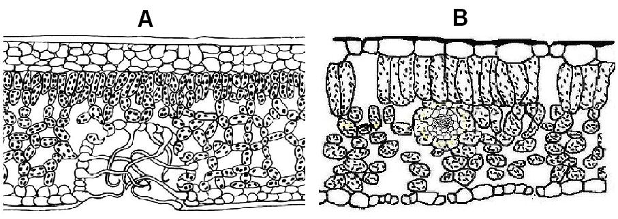

Diagram A - Bgqhrsnog (2006) Cross section through a xerophyte leave. http://commons.wikimedia.org/wiki/File:Xerophyten_-_Blattanatomie.png. Accessed 5 October, 2009

Diagram B - Maksim (2006) File:Blad dwarsdoorsnede.jpg. http://commons.wikimedia.org/wiki/File:Blad_dwarsdoorsnede.jpg. Accessed 5 October 2009

  - Which plant is adapted to survive in arid conditions?
Plant A
1 mark

  - Briefly describe three adaptations evident in this leaf cross section that support this inference.( Mark first three only)
Stomata are sunken below the leaf surface (1)/ located on the underside of the leaf (1)/
Leaf hairs/epidermal hairs maintain humid air around the stomatal pores(1)/ Thick cuticle (1)
(Any three)
3 marks

  - Describe a physiological adaptation of an arid climate plant:
Stomata close when water is insufficient (1)
This enables survival in dry conditions by reducing water loss.(1)
2 marks

  - Maintenance of water balance and moderate temperature is vital for the functioning of a plant. Describe why a plant needs to maintain these two factors within an acceptable level in order to continue functioning normally.
Plants need water to keep stomata open (1) Plants use water in photosynthesis (1)
Plant cells will dehydrate if there is insufficient water (1)plants need water for support (1)
High temperatures denature proteins(1)/ enzyme activity reduced at high temperatures(1) High temps increase water loss (1)
Low temperatures reduce metabolic rate/rate of diffusion/ activation energy (1)/ Extremely low temperatures cause the water in cells to expand as it freezes, damaging the cells.(1)
Two marks for water and two marks for temperature =4 marks

- The red kangaroo (Macropus rufus) is a large marsupial that lives in the arid and semi arid regions of central Australia. They feed on native grasses in these regions, moving great distances to find suitable food and water sources.

A study on red kangaroos demonstrated that at high temperatures (40 - 44 ºC) and moderate humidity they regulated their body temperature well by increasing respiratory rate, while maintaining pulse rate and body temperatures at normal levels. When the humidity was increased the animals became heat stressed, with an increase in pulse rate and a 2ºC increase in body temperature.

  - Explain how an increase in breathing rate allowed the kangaroo to modulate their body temperature.
Increasing breathing rate increases evaporation of water.(1)
Evaporation of water removes heat from the body(1)
2 marks

  - Explain why increasing humidity affected the kangaroo’s abilities to control their body temperature this way.
Increasing humidity reduces the rate of evaporation of water.(1)
The kangaroo is unable to lose sufficient heat by evaporative cooling. (1)
2 marks

  - Describe one way red kangaroos may lose water and an adaptation they may have to reduce water loss by this method.
Any 1 method (1) and any matching adaptation (1) e.g.
Kangaroos lose water in urine (1) They can produce a concentrated urine (1) in dry conditions/have long loops of Henle (1)
2 marks

  - Red kangaroos have been observed grazing on grasses in “moisture run-on” zones (areas where moisture accumulates after rain) in their arid habitat. They also feed more around dusk and dawn, which coincides with higher transpiration rates in the plants they feed on.

Discuss how these behaviours are adaptations to an arid habitat.
The grasses in the” moisture run on” zones will contain more water.(1)
Dusk and dawn will be cooler, reducing evaporative water loss(1)
Higher transpiration rates increase humidity, reducing evaporative water loss (1).
Higher humidity at lower temperatures will increase dew, increasing water input (1)
4 marks

